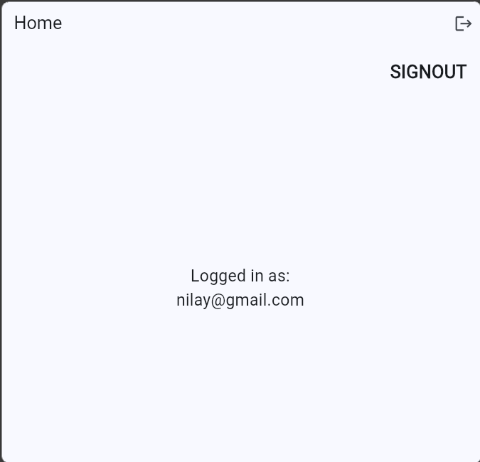

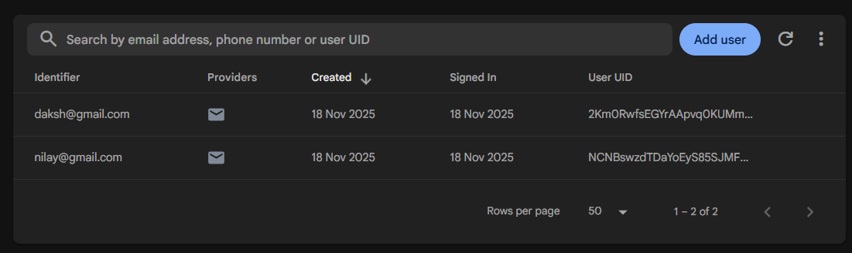

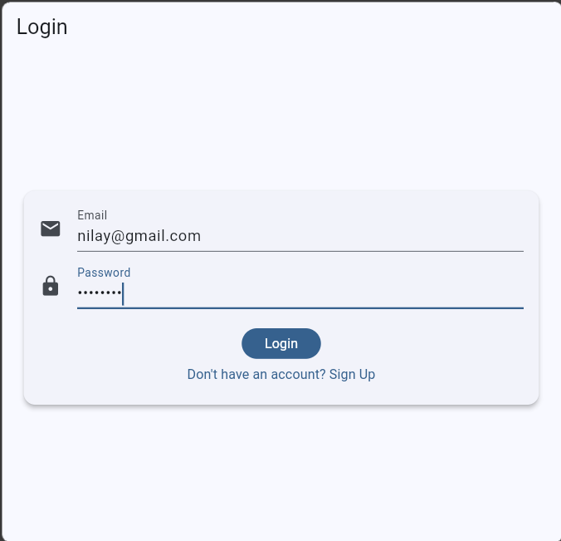
import 'package:flutter/material.dart';
import 'package:firebase_core/firebase_core.dart';
import 'package:firebase_auth/firebase_auth.dart';
import 'auth_service.dart';
import 'firebase_options.dart';
final AuthService _auth = AuthService();
Future<void> main() async {
WidgetsFlutterBinding.ensureInitialized();
await Firebase.initializeApp(options: DefaultFirebaseOptions.currentPlatform);
runApp(const MyApp()); }

class MyApp extends StatelessWidget {
const MyApp({super.key});
@override
Widget build(BuildContext context) {
return MaterialApp(
debugShowCheckedModeBanner: false,
title: 'Firebase Auth Demo',
theme: ThemeData(useMaterial3: true, colorSchemeSeed: Colors.blue),
home: const AuthGate(), ); } }
class AuthGate extends StatelessWidget {
const AuthGate({super.key});
@override
Widget build(BuildContext context) {
return StreamBuilder<User?>(
stream: _auth.authStateChanges,
builder: (context, snapshot) {
if (snapshot.connectionState == ConnectionState.waiting) {
return const Scaffold(
body: Center(child: CircularProgressIndicator()), ); }
if (snapshot.hasData) {
return const HomePage(); }
return const LoginScreen(); }, ); } }
// LOGIN + SIGNUP SCREEN
class LoginScreen extends StatefulWidget {
const LoginScreen({super.key});
@override
State<LoginScreen> createState() => _LoginScreenState(); }
class _LoginScreenState extends State<LoginScreen> {
bool isLogin = true;
bool loading = false;
final _email = TextEditingController();
final _password = TextEditingController();
final _formKey = GlobalKey<FormState>();
Future<void> submit() async {
if (!_formKey.currentState!.validate()) return;
setState(() => loading = true);
try {
if (isLogin) {
await _auth.signIn(
email: _email.text.trim(),
password: _password.text.trim(), );
} else {
await _auth.createAccount(
email: _email.text.trim(),
password: _password.text.trim(), ); }
} on FirebaseAuthException catch (e) {
ScaffoldMessenger.of( context,
).showSnackBar(SnackBar(content: Text(e.message ?? "Error")));
} finally {
if (mounted) setState(() => loading = false); } }
@override
Widget build(BuildContext context) {
return Scaffold(
appBar: AppBar(title: Text(isLogin ? "Login" : "Sign Up")),
body: Center(
child: SingleChildScrollView(
padding: const EdgeInsets.all(20),
child: Card(
elevation: 4,
child: Padding(
padding: const EdgeInsets.all(16),
child: Form(
key: _formKey,
child: Column(
mainAxisSize: MainAxisSize.min,
children: [
TextFormField(
controller: _email,
decoration: const InputDecoration(
labelText: 'Email',
icon: Icon(Icons.email), ),
validator: (v) =>
v == null || v.isEmpty || !v.contains("@")
? "Enter valid email"
: null, ),
const SizedBox(height: 12),
TextFormField(
controller: _password,
decoration: const InputDecoration(
labelText: 'Password',
icon: Icon(Icons.lock), ),
obscureText: true,
validator: (v) => v != null && v.length >= 6
? null
: "Min 6 characters", ),
const SizedBox(height: 20),
loading
? const CircularProgressIndicator()
: FilledButton(
onPressed: submit,
child: Text(isLogin ? "Login" : "Create Account"), ),
TextButton(
onPressed: () => setState(() => isLogin = !isLogin),
child: Text(
isLogin
? "Don't have an account? Sign Up"
: "Already have an account? Login",),),],),),),),),),); } }
// HOME
class HomePage extends StatelessWidget {
const HomePage({super.key});
@override
Widget build(BuildContext context) {
final user = _auth.currentUser;
return Scaffold(
appBar: AppBar(
title: const Text("Home"),
actions: [
IconButton(
icon: const Icon(Icons.logout),
onPressed: () => _auth.signOut(), ), ], ),
body: Column(
crossAxisAlignment: CrossAxisAlignment.stretch,
children: [
// TOP RIGHT SIGNOUT TEXT
Padding(
padding: const EdgeInsets.all(16.0),
child: Row(
mainAxisAlignment: MainAxisAlignment.end,
children: [
Text(
"SIGNOUT",
style: TextStyle(fontSize: 22, fontWeight: FontWeight.bold), ), ], ), ),
const SizedBox(height: 20),
// CENTER EMAIL TEXT
Expanded(
child: Center(
child: Text(
"Logged in as:\n${user?.email}",
textAlign: TextAlign.center,
style: const TextStyle(fontSize: 20),), ), ), ], ), ); } }

